- Custom chatbot to fetch the user story from JIRA
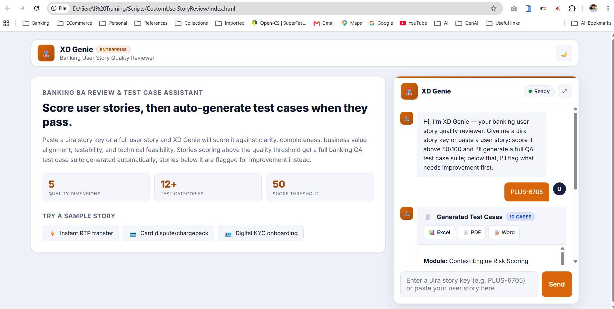
- Customized to show the no of quality checks, test categories and the requirement review threshold.
If the score is < 50 – It will say requirement is not upto mark and will not generate test cases as per Langflow.
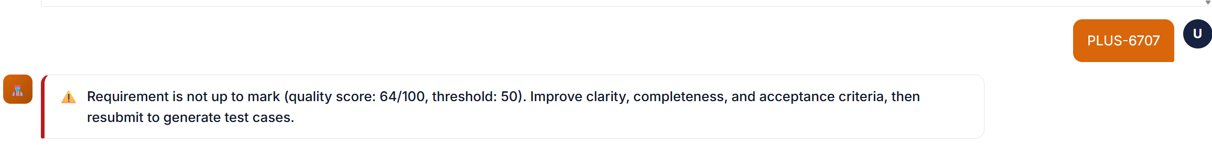
If the score is > 50 – It will generate test cases

- You can expand the chat window to view the details clearly
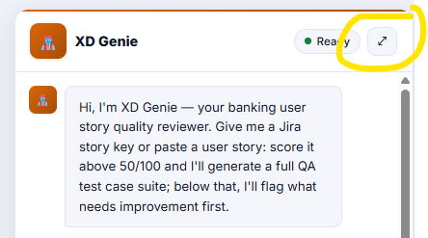
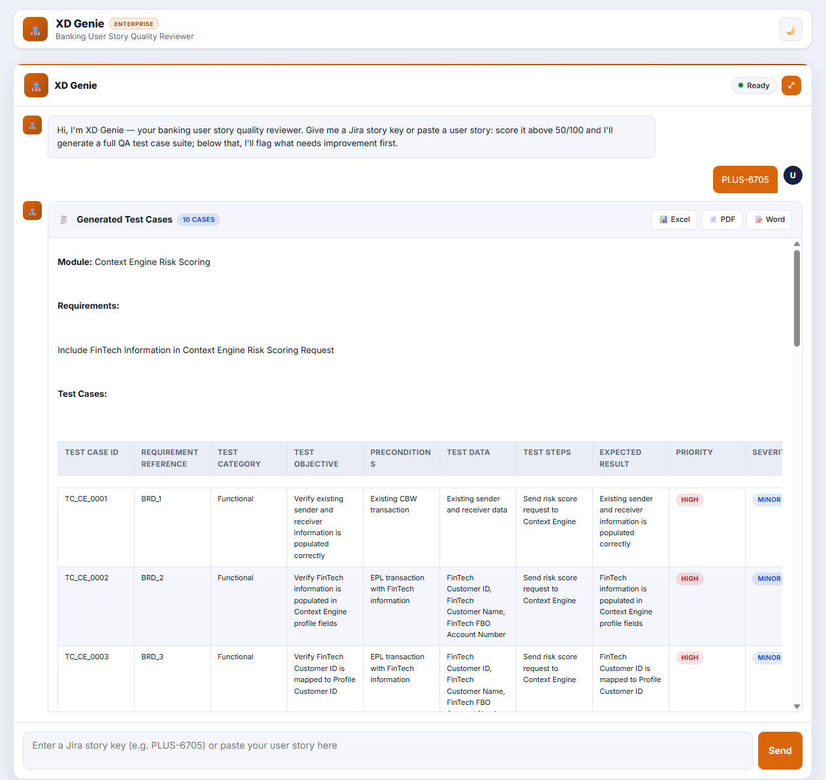

- You can export to required format
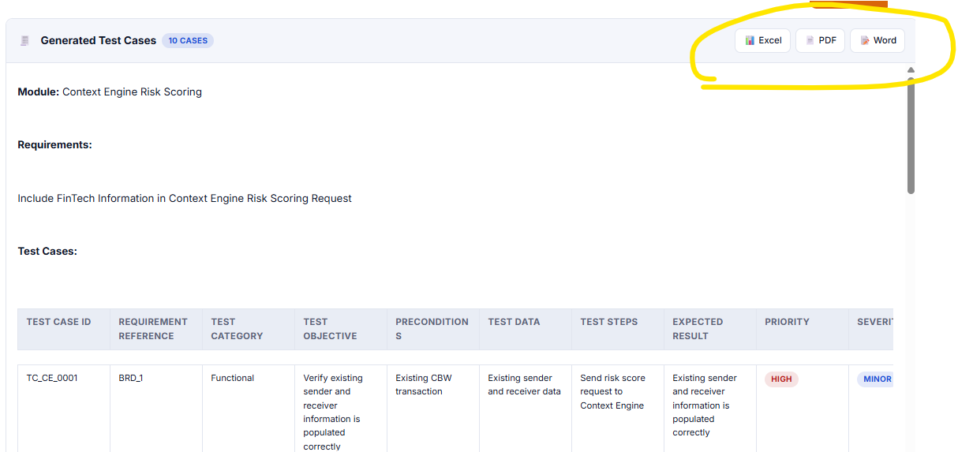

- Also it provides Requirement Traceability, Test Coverage, Requirement Gaps, Risk & Dependencies, Recommended Automation Scope.
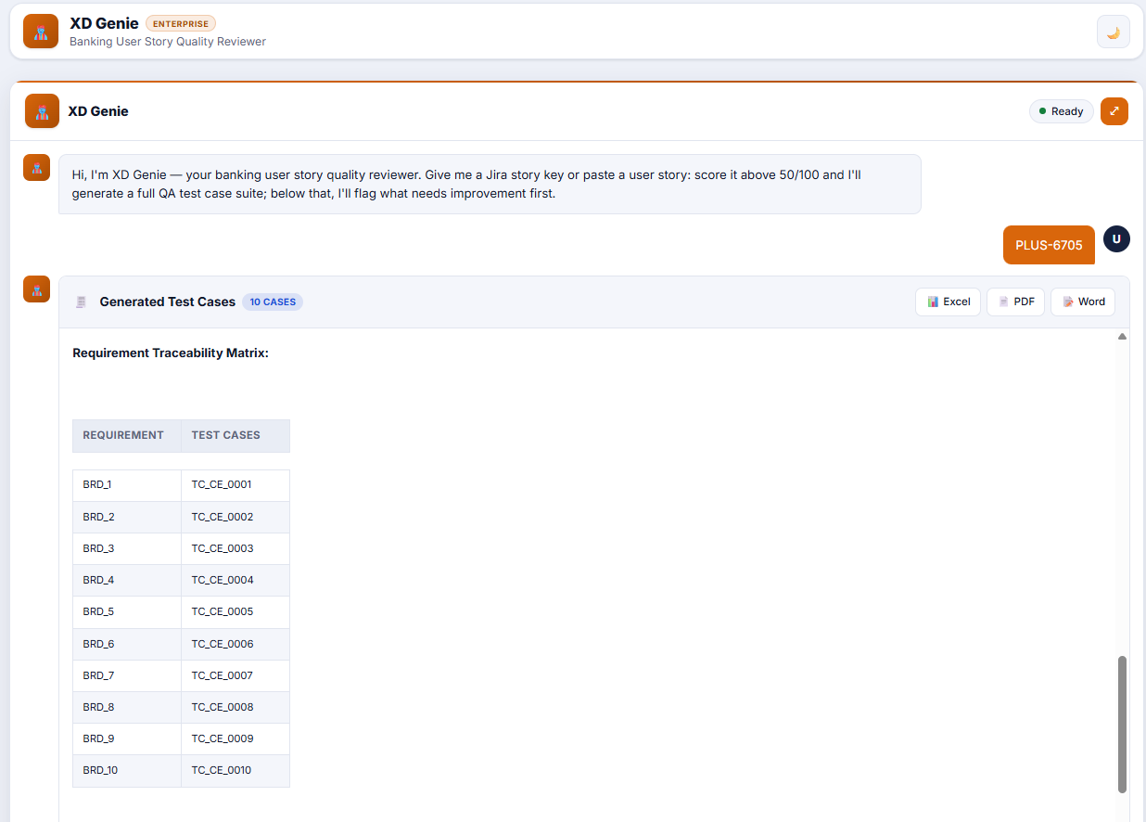
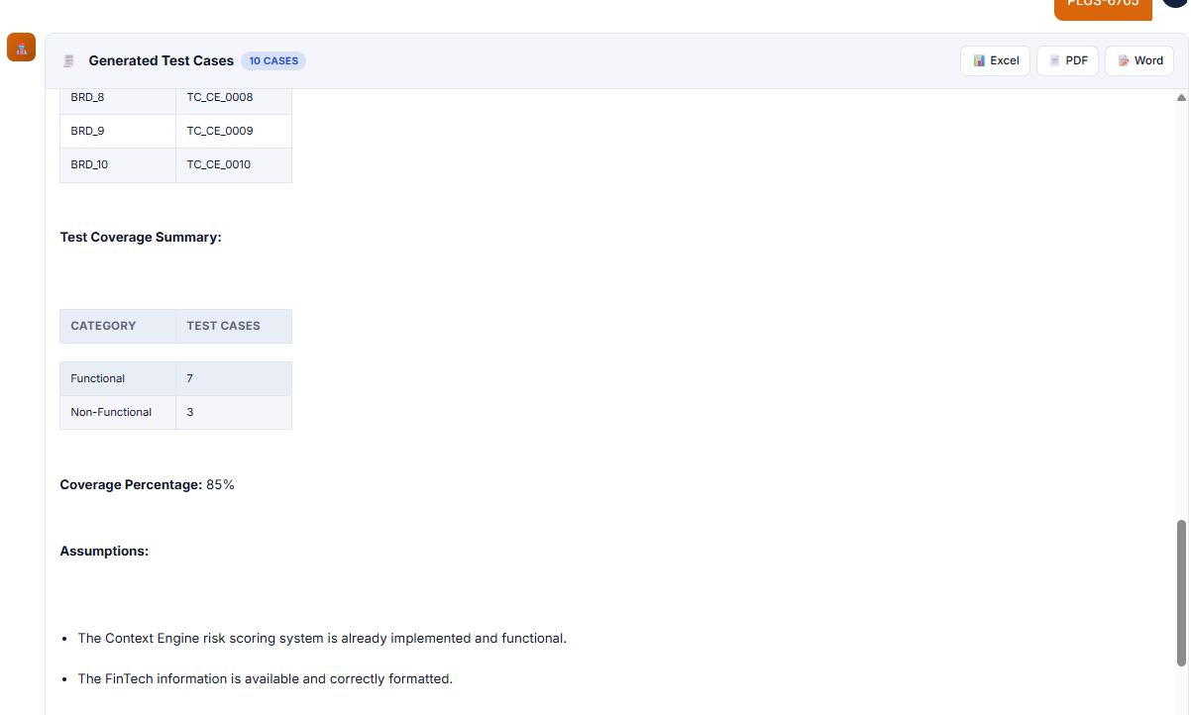
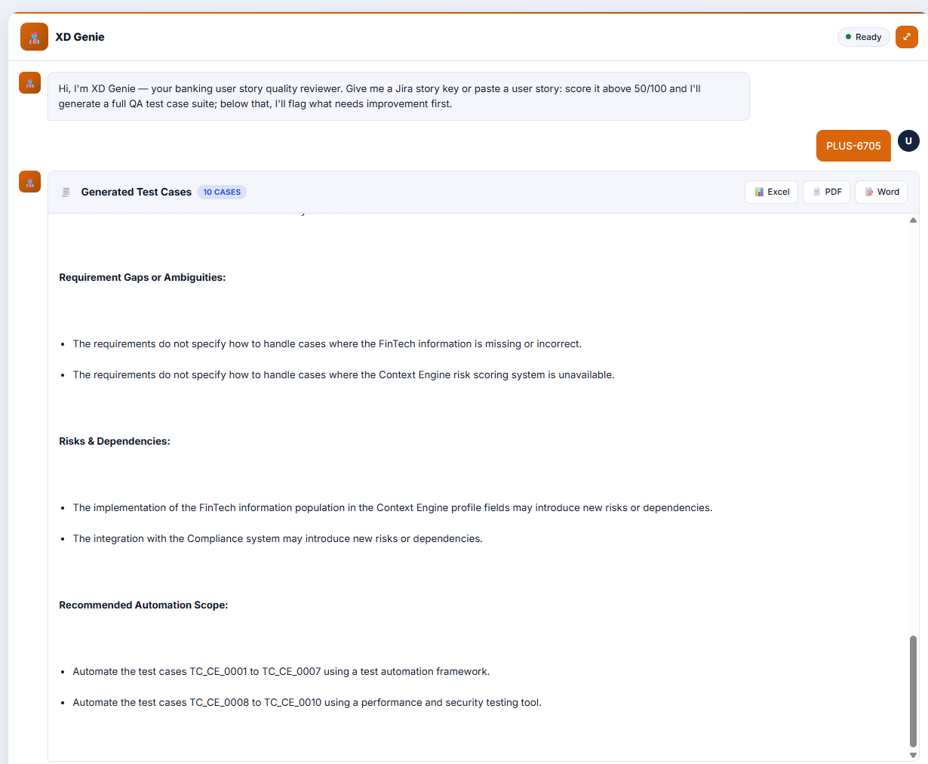

Config.js
